# 

# Baseline Audit

**Target Market**

Little Mountain Vet Clinic’s has a vast target market segment that can be utilized to help boost brand awareness and sales. The first target market is families who have one or more dogs and have a disposable income with money to give their pets treatment. The second target market is the opposite end of the spectrum with families who own more than one cat and have the disposable income with money to give their pets treatment. Both target markets desire great customer service, professional expertise, along with the sense of comfort and ease for the pet and owner.

# Compliments

|  |  |  |  |
| --- | --- | --- | --- |
| Compliments | | | |
|  | Summary: | Location: | Explanation: |
| 1 | Amazing Service | Facebook | “Whole staff was great, and the doctor was better” For a service company service is number one. |
| 2 | Friendly Staff | Google Review | Building brand loyalty through great customer service and friendly staff. Many comments mentioned how great it was for the staff to remember the pet’s names. |
| 3 | Passionate Staff | Facebook | Customer realized how the staff is passionate about the animals and are doing more than the average employee. This shows authenticity, one of the best reviews companies can receive. |
| 4 | Down to earth, Calm environment | Google Review | Customers realized the calm environment for them and their pet. This is a competitive advantage over a crowded vet with many distraction and other animals. |

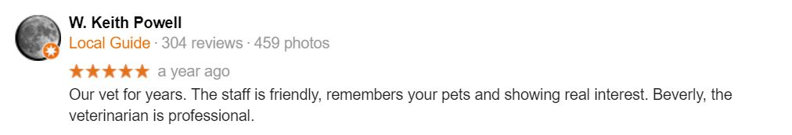**Screenshots of Customer Compliments**

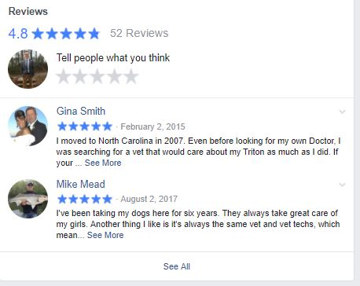

# Complaints

|  |  |  |  |
| --- | --- | --- | --- |
| Complaints | | | |
|  | Summary: | Location: | Explanation: |
| 1 | “Vet is in it for the cash” | Facebook | Claims they were fed misinformation only wanting to make money by telling customer they need to come back every 6 months for a heartworm check. |
| 2 | To Expensive | Google Review | Claims they were charged $45 for a 10-minute session where doctor told them to go elsewhere. |
| 3 | Money over animal | Google Review | Customer turned away pain med for puppy because can’t have made payment until 4 days later. Puppy bite by other dog and still refused pain meds worth $13. |
|  |  |  |  |

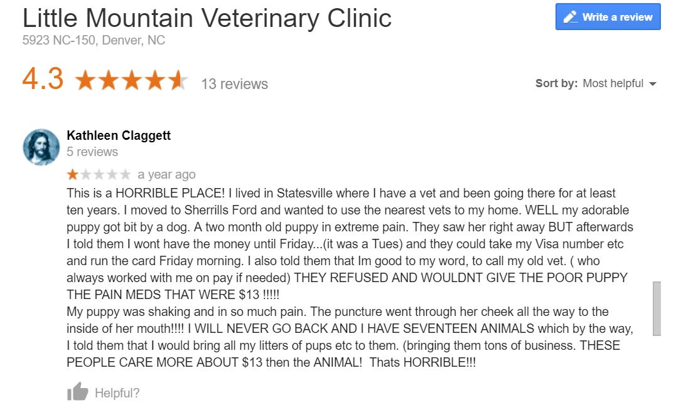**Screenshots of Customer Complaints**

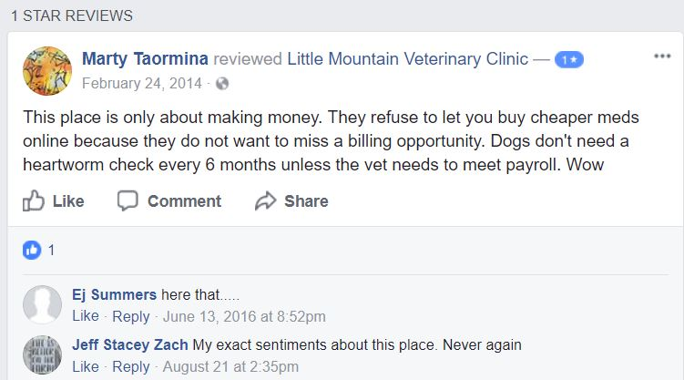

# Trends

|  |  |
| --- | --- |
| Trends | |
| Summary: | Explanation: |
| Largely more positive than negative | Most of reviews on Facebook and Google.com are largely positive with the outlier of a couple negatives |
| Similar reviews | Most reviews are about the great staff and service. Some reviews said fairly priced. |

**Trends Screenshots**

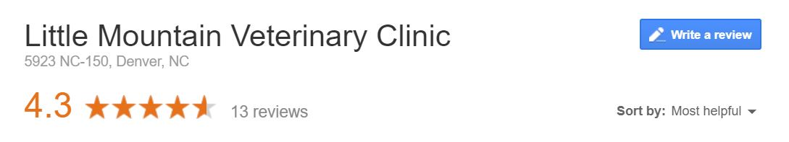

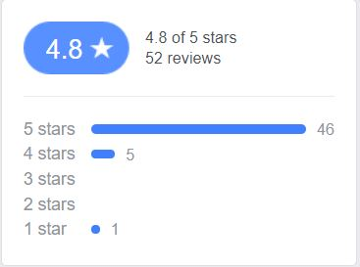

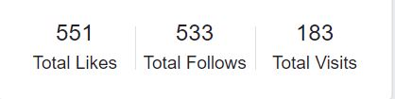

# Competitive Chatter

|  |  |  |
| --- | --- | --- |
| Competitive Chatter | | |
|  | Company: | What are they saying? |
| 1 | Denver Animal Emergency | * Great service * Active In reviews and social media * Responds to bad and good reviews * Passionate Staff |
| 2 | West Shore Animal Hospital | * Lowest rating out of competitors * Insulting Customers openly on reviews * Some great service review, some claim overcharged |
| 3 | East Lincoln Animal Hospital | * Claims of best doctor in Denver (Local Guide) * 2 claims of malpractice * Largest review count (Best social media presents) |

**Competitive Chatter Screenshots**

**Denver Animal Emergency:**

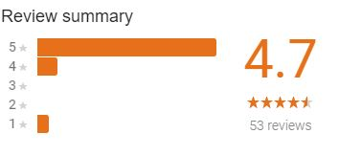

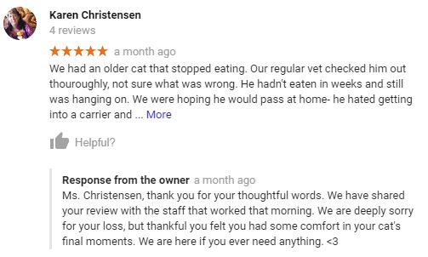

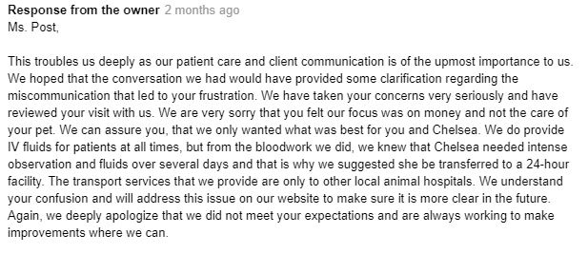

**West Shore Animal Hospital:**

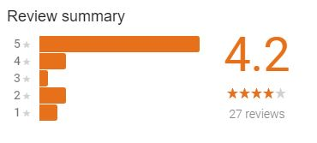

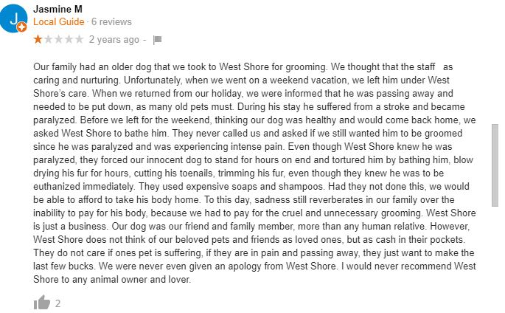

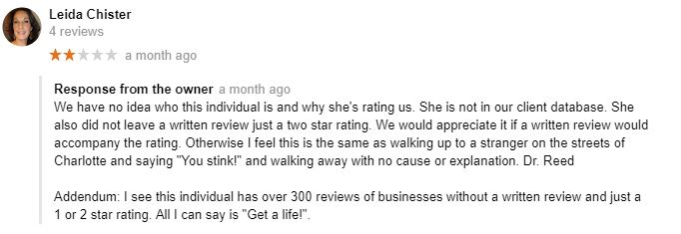**WHAT NOT TO DO!**

**East Lincoln Animal Hospital**

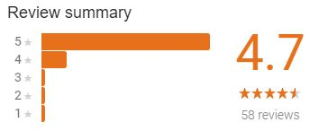

**FACEBOOK:**

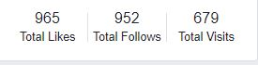

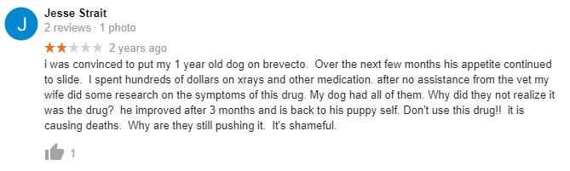

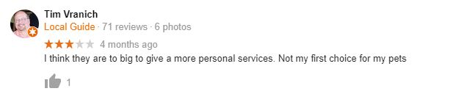Competitive advantage: **Customer service**

Reply to customer Complaints and Compliments

How you handle and reply to customer complaints is critical to any company. Although complaints are inevitable, companies might be able to leverage a complaint, respond appropriately, and actually benefit from a complaint. Responding in a timely, and apologetic fashion shows customers that you truly care about finding a solution.

* Strive to be transparent and apologetic
* Admit you made a mistake
* Take complaints as a learning experience

# Influencers

Social media influencers are individuals interacting with your organization that have a great ability to spread a positive or negative image of your company throughout the internet. It is especially critical to interact with these individuals positively because of their social span of influence. The Charts below are people who are talking about your company on the web who have considerable influence on the number of individual they can impact with their opinions.

**Facebook: 4.8**

|  |  |  |
| --- | --- | --- |
| Name: | Credentials: | Rating: |
| Gina Smith | 500+ Facebook Friends | 5 stars |
| Kacie Renegar | 1000+ Facebook friends   * Target Market * Middle aged * Family * 2 dogs | 5 stars |
| Mary Anne Ellison | 500+ Facebook Friends   * Target Market * Cats | 5 stars |

Facebook has quickly become one of the most popular forms of social media advertising for many companies. With the like button feature, you can receive an online endorsement from your customers that can be seen by hundreds of their friends.  The median Facebook following is 200 friends, the individual above far outreach those numbers and with the right responses to their post, ratings, and comments you could create a strong, online brand advocate

**Google Review: 4.3**

|  |  |
| --- | --- |
| Name: | Rating: |
| W. Keith Powell (Local Guide) | 5 star |
| Patrick LaJuett (Local Guide) | 5 star |
| Kathleen Claggett | 1 star |

Google is the internet’s most popular search engine, and Google reviews are the first thing potential customers see when searching for your company. Above are reviews from “Local guides,” individuals who are googles most active users. Persons with the “Local guide description have a star by their name allowing other users see them with prestige and add weight to their online recommendations.  Responding quickly and appropriately to the users is a great way to build a strong first impression for your company with potential customers.

Weakest Large Influencers:

* Twitter
* Instagram
* Yelp

**BASELINE KEYWORDS**

|  |  |  |  |
| --- | --- | --- | --- |
| Baseline Keywords | | | |
|  | **Word/Phrase** | **Niche/Mainstream** |  |
| 1 | Vet Clinic | Mainstream |  |
| 2 | Spay | Mainstream |  |
| 3 | Neuter | Mainstream |  |
| 4 | Denver, NC | Niche |  |
| 5 | North Carolina | Mainstream |  |
| 6 | Dog “ “ | Niche |  |
| 7 | Cat “ “ | Niche |  |
| 8 | Little Mountain | Niche |  |
| 9 | Rabies Shot | Niche |  |
| 10 | Puppy | Mainstream |  |
| 11 | Kitten | Mainstream |  |
| 12 | Pet Boarding | Mainstream |  |
| 13 | Shot records | Niche |  |
| 14 | Highway 16 | Niche |  |
| 15 | Veterinarian | Mainstream |  |
| 16 | Animal | Mainstream |  |
| 17 | Procedure | Mainstream |  |
| 18 | Health | Mainstream |  |
| 19 | Bloodwork | Niche |  |
| 20 | Tapeworm | Niche |  |